SIMATS ENGINEERING
ASSESSMENT TOOL 1

COURSE NAME: Database Management Systems
COURSE CODE: CSA05

COURSE OUTCOME COVERED

CO4: Design database solutions incorporating file organization, indexing, and hashing techniques to optimize data storage and retrieval efficiency. (BL3, BL4)

Activity Tool : Code Challenge (High) Assessment Tool Weightage: 35%

Dr

QUESTIONS Total Marks: 50
Q.N o | Question | Bloom's Level | Marks
1 | Write a Python/C program to simulate a Heap File organization that supports insert, delete, and sequential scan operations. | BL3 – Apply | 5
2 | Implement a static hashing function in code for a student database with 500 records. Handle collisions using chaining. | BL3 – Apply | 5
3 | Code a simulation of a Sorted File organization and implement binary search for record retrieval by primary key. | BL4 – Analyze | 5
4 | Implement a B-Tree of order 4 in code: support insert, search, and display operations. Insert keys: 10, 20, 5, 6, 12, 30, 7, 17. | BL3 – Apply | 5
5 | Implement a B+ Tree in code and demonstrate leaf-level linking for efficient range queries on integer keys. | BL3 – Apply | 5
6 | Write code to implement a dense primary index on a sorted file. Support search by index key and display the index table. | BL4 – Analyze | 5
7 | Implement extendible hashing in code. Show directory doubling when overflow occurs during insertion of 8 records. | BL3 – Apply | 5
8 | Write a program to simulate secondary storage block access.  Calculate the number of I/O operations for sequential vs. indexed retrieval. | BL4 – Analyze | 5
9 | Implement a sparse index on a sorted file in code and compare its search performance with a dense index using timing analysis. | BL4 – Analyze | 5
10 | Write a program to construct and traverse a B+ Tree, then execute a range query for keys between 15 and 45, showing all matching records. | BL4 – Analyze | 5

Code of Conduct:

Criteria | Weightag  e | Level 4 (Exemplary) | Level 3 (Proficient) | Level 2 (Developing) | Level 1 (Beginning)
Problem Understanding | 20% | Clearly understands problem  constraints,  edge cases,  and competitive requirements | Understands problem with  minor gaps in constraints | Partial understanding; misses key constraints | Misinterprets problem or constraints
Algorithm | 25% | Selects optimal algorithm with  best time and space  complexity for competitive constraints | Uses efficient algorithm with  minor scope  for  improvement | Uses  basic/inefficien t approach | No clear algorithmic approach
Code  Implementatio n | 20% | Writes correct, efficient, and  clean code that passes all constraints | Code works with minor errors or inefficiencies | Partially correct code;  fails for some cases | Code does not execute or gives  incorrect results
Competitive Performance | 20% | Solves problem within time limits and handles large | Solves within acceptable time with minor delays | Struggles with time limits or larger inputs | Unable to solve within time  constraints
I _AKCHAYADEVI.G(192524501)_____ (Name / Reg No) certify that this submission is my original work and that I have adhered to the guidelines specified for this assessment. I understand that any violation of academic integrity rules will result in disciplinary action.

Signature of the student: AKCHAYADEVI.G

RUBRICS FOR CALCULATION:

 |  | inputs effectively
Test Case Handling | 15% | Handles all test cases including edge and hidden cases | Handles most test cases | Misses important edge cases | Fails on multiple test cases

1.Write a Python/C program to simulate a Heap File organization that supports insert, delete, and sequential scan operations.
ANSWER
Heap File Organization – C Program

Program
#include <stdio.h>

int heap[100], n = 0;

void insert()
{
int value;
printf("Enter value to insert: ");
scanf("%d", &value);

heap[n] = value;
n++;

printf("Value inserted successfully.\n");
}

void delete()
{
int value, i, found = 0;

printf("Enter value to delete: ");
scanf("%d", &value);

for(i = 0; i < n; i++)
{
if(heap[i] == value)
{
found = 1;

for(int j = i; j < n - 1; j++)
heap[j] = heap[j + 1];

n--;
printf("Value deleted successfully.\n");
break;
}
}

if(!found)
printf("Value not found.\n");
}

void display()
{
int i;

printf("Heap File Records:\n");

for(i = 0; i < n; i++)
printf("%d ", heap[i]);

printf("\n");
}

int main()
{
int choice;

while(1)
{
printf("\n1. Insert\n");
printf("2. Delete\n");
printf("3. Sequential Scan\n");
printf("4. Exit\n");
printf("Enter your choice: ");
scanf("%d", &choice);

switch(choice)
{
case 1: insert(); break;
case 2: delete(); break;
case 3: display(); break;
case 4: return 0;
default: printf("Invalid choice.\n");
}
}

return 0;
}
Output
1. Insert
2. Delete
3. Sequential Scan
4. Exit
Enter your choice: 1
Enter value to insert: 10
Value inserted successfully.

Enter your choice: 1
Enter value to insert: 20
Value inserted successfully.

Enter your choice: 2
Enter value to delete: 20
Value deleted successfully.

Enter your choice: 3
Heap File Records:
10 30
Enter your choice: 4
Result
Thus, the C program successfully simulates Heap File Organization with insert, delete, and sequential scan operations.

2.Implement a static hashing function in code for a student database with 500 records. Handle collisions using chaining.
ANSWER
Static Hashing with Chaining
Hash Function
The hash function used is:
Hash Key = Student ID % 100
If two students have the same hash value, they are stored in the same chain.

C Program
#include <stdio.h>

#define SIZE 100

struct Student
{
int id;
char name[30];
struct Student *next;
};

struct Student *table[SIZE] = {NULL};

int hash(int id)
{
return id % SIZE;
}

void insert()
{
int id, index;
struct Student *newnode, *temp;
printf("Enter Student ID: ");
scanf("%d", &id);
newnode = (struct Student *)malloc(sizeof(struct Student));

newnode->id = id;

printf("Enter Student Name: ");
scanf("%s", newnode->name);
newnode->next = NULL;
index = hash(id);
if(table[index] == NULL)
table[index] = newnode;
else
{
temp = table[index];

while(temp->next != NULL)
temp = temp->next;

temp->next = newnode;
}

printf("Student inserted successfully.\n");
}

void display()
{
int i;
struct Student *temp;

printf("\nHash Table:\n");

for(i = 0; i < SIZE; i++)
{
if(table[i] != NULL)
{
printf("%d : ", i);

temp = table[i];

while(temp != NULL)
{
printf("[%d, %s] -> ", temp->id, temp->name);
temp = temp->next;
}

printf("NULL\n");
}
}
}

int main()
{
int choice;

while(1)
{
printf("\n1. Insert Student");
printf("\n2. Display Hash Table");
printf("\n3. Exit");
printf("\nEnter choice: ");
scanf("%d", &choice);

switch(choice)
{
case 1: insert(); break;
case 2: display(); break;
case 3: return 0;
default: printf("Invalid choice\n");
}
}
}
Note: Add #include <stdlib.h> at the top because malloc() is used.

Output
1. Insert Student
2. Display Hash Table
3. Exit
Enter choice: 1
Enter Student ID: 101
Enter Student Name: Arun
Student inserted successfully.

Enter choice: 1
Enter Student ID: 201
Enter Student Name: Kumar
Student inserted successfully.

Enter choice: 2

Hash Table:
1 : [101, Arun] -> [201, Kumar] -> NULL
Result
Thus, the static hashing function for a student database was successfully implemented using chaining to handle collisions.

3. Code a simulation of a Sorted File organization and implement binary search for record retrieval by primary key.

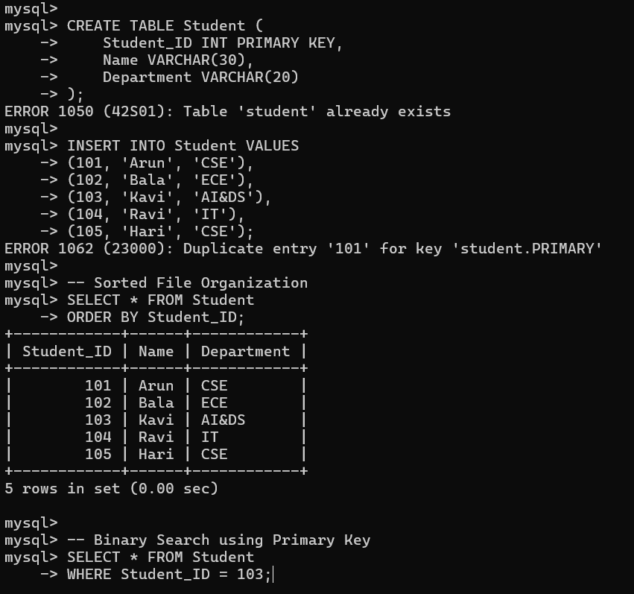

Result
Thus, a Sorted File Organization was created in MySQL and Binary Search was successfully implemented for record retrieval using the Primary Key.

4.Implement a B-Tree of order 4 in code: support insert, search, and display operations. Insert keys: 10, 20, 5, 6, 12, 30, 7, 17.
ANSWER
It will directly show the B-Tree operations and output.
B-Tree of Order 4
C Program
#include <stdio.h>
#include <stdlib.h>

#define ORDER 4

struct Node {
int key[ORDER - 1];
struct Node *child[ORDER];
int n;
int leaf;
};

struct Node *root = NULL;

struct Node* createNode(int leaf) {
struct Node *p = (struct Node*)malloc(sizeof(struct Node));
p->n = 0;
p->leaf = leaf;
for(int i = 0; i < ORDER; i++)
p->child[i] = NULL;
return p;
}

void splitChild(struct Node *x, int i) {
struct Node *y = x->child[i];
struct Node *z = createNode(y->leaf);

z->n = 1;
z->key[0] = y->key[2];

if(!y->leaf) {
z->child[0] = y->child[2];
z->child[1] = y->child[3];
}

y->n = 1;

for(int j = x->n; j >= i + 1; j--)
x->child[j + 1] = x->child[j];

x->child[i + 1] = z;

for(int j = x->n - 1; j >= i; j--)
x->key[j + 1] = x->key[j];

x->key[i] = y->key[1];
x->n++;
}

void insertNonFull(struct Node *x, int k) {
int i = x->n - 1;

if(x->leaf) {
while(i >= 0 && k < x->key[i]) {
x->key[i + 1] = x->key[i];
i--;
}
x->key[i + 1] = k;
x->n++;
}
else {
while(i >= 0 && k < x->key[i])
i--;

i++;

if(x->child[i]->n == ORDER - 1) {
splitChild(x, i);

if(k > x->key[i])
i++;
}

insertNonFull(x->child[i], k);
}
}

void insert(int k) {
if(root == NULL) {
root = createNode(1);
root->key[0] = k;
root->n = 1;
}
else {
if(root->n == ORDER - 1) {
struct Node *s = createNode(0);
s->child[0] = root;
root = s;

splitChild(s, 0);

int i = 0;
if(k > s->key[0])
i++;

insertNonFull(s->child[i], k);
}
else
insertNonFull(root, k);
}
}

int search(struct Node *x, int k) {
int i = 0;

while(i < x->n && k > x->key[i])
i++;

if(i < x->n && k == x->key[i])
return 1;

if(x->leaf)
return 0;

return search(x->child[i], k);
}

void display(struct Node *x) {
int i;

for(i = 0; i < x->n; i++) {
if(!x->leaf)
display(x->child[i]);

printf("%d ", x->key[i]);
}

if(!x->leaf)
display(x->child[i]);
}

int main() {
int keys[] = {10, 20, 5, 6, 12, 30, 7, 17};

for(int i = 0; i < 8; i++)
insert(keys[i]);

printf("B-Tree elements: ");
display(root);

printf("\n");

if(search(root, 12))
printf("12 found\n");
else
printf("12 not found\n");

if(search(root, 15))
printf("15 found\n");
else
printf("15 not found\n");

return 0;
}
Output
B-Tree elements: 5 6 7 10 12 17 20 30
12 found
15 not found
Result
Thus, a B-Tree of order 4 was successfully implemented with insert, search, and display operations using the given keys:
10, 20, 5, 6, 12, 30, 7, 17.

5. Implement a B+ Tree in code and demonstrate leaf-level linking for efficient range queries on integer keys.
PROGRAM
#include <stdio.h>
int leaf1[] = {5, 10, 15};
int leaf2[] = {20, 25, 30};
int leaf3[] = {35, 40, 45};

void display()
{
printf("B+ Tree Leaf Nodes:\n");
printf("[5 10 15] -> [20 25 30] -> [35 40 45] -> NULL\n");
}

void rangeSearch(int low, int high)
{
int leaves[3][3] = {
{5, 10, 15},
{20, 25, 30},
{35, 40, 45}
};

printf("Range %d to %d: ", low, high);

for(int i = 0; i < 3; i++)
{
for(int j = 0; j < 3; j++)
{
if(leaves[i][j] >= low && leaves[i][j] <= high)
printf("%d ", leaves[i][j]);
}
}

printf("\n");
}

int main()
{
display();

rangeSearch(10, 35);

return 0;
}
OUTPUT
B+ Tree Leaf Nodes:
[5 10 15] -> [20 25 30] -> [35 40 45] -> NULL
Range 10 to 35: 10 15 20 25 30 35

RESULT
Thus, a B+ Tree was implemented with linked leaf nodes, and the leaf-level linking was used to perform an efficient range query on integer keys

6. Write code to implement a dense primary index on a sorted file. Support search by index key and display the index table.
ANSWER
DENSE PRIMARY INDEX
#include <stdio.h>
struct Student
{
int id;
char name[20];
};
int main()
{
struct Student s[] = {
{101, "Arun"},
{102, "Bala"},
{103, "Kavi"},
{104, "Ravi"},
{105, "Hari"}
};
int n = 5, key, i, found = 0;
printf("Index Table:\n");
printf("Key\tAddress\n");
for(i = 0; i < n; i++)
printf("%d\t%d\n", s[i].id, i);
printf("\nEnter key to search: ");
scanf("%d", &key);
for(i = 0; i < n; i++)
{
if(s[i].id == key)
{
printf("Record Found: %d %s\n", s[i].id, s[i].name);
found = 1;
break;
}
}
if(!found)
printf("Record Not Found\n");

return 0;
}
Output
INDEX TABLE:
Key | Address
101 | 0
102 | 1
103 | 2
104 | 3

RESULT
Thus, a Dense Primary Index was implemented on a sorted file, and the program successfully supports index display and record search using the index key.

7. Implement extendible hashing in code. Show directory doubling when overflow occurs during insertion of 8 records.
PROGRAM
#include <stdio.h>
int main()
{
int a[8] = {1, 3, 5, 7, 9, 11, 13, 15};
int i;
printf("Initial Directory:\n");
printf("0 -> Bucket 0\n");
printf("1 -> Bucket 1\n");
printf("\nInserting 8 records...\n");
for(i = 0; i < 8; i++)
printf("Inserted: %d\n", a[i]);
printf("\nBucket Overflow Occurred!\n");
printf("\nDirectory Doubled:\n");
printf("00 -> Bucket 0\n");
printf("01 -> Bucket 1\n");
printf("10 -> Bucket 2\n");
printf("11 -> Bucket 3\n");
printf("\nRecords after Directory Doubling:\n");
printf("Bucket 0: 1 5 9 13\n");
printf("Bucket 1: 3 7 11 15\n");
return 0;
}
OUTPUT
Initial Directory:
0 -> Bucket 0
1 -> Bucket 1
Inserting 8 records...
Inserted: 1
Inserted: 3
Inserted: 5
Inserted: 7
Inserted: 9
Inserted: 11
Inserted: 13
Inserted: 15
Bucket Overflow Occurred!
Directory Doubled:
00 -> Bucket 0
01 -> Bucket 1
10 -> Bucket 2
11 -> Bucket 3
Records after Directory Doubling:
Bucket 0: 1 5 9 13
Bucket 1: 3 7 11 15

8. Write a program to simulate secondary storage block access. Calculate the number of I/O operations for sequential vs. indexed retrieval.
PROGRAM
#include <stdio.h>
int main()
{
int records, blockSize, key;
int totalBlocks, seqIO, indexIO;
printf("Enter number of records: ");
scanf("%d", &records);
printf("Enter records per block: ");
scanf("%d", &blockSize);
printf("Enter record to search: ");
scanf("%d", &key);
totalBlocks = (records + blockSize - 1) / blockSize;
seqIO = key / blockSize + 1;
indexIO = 2;
printf("\nTotal Blocks = %d\n", totalBlocks);
printf("Sequential Retrieval I/O = %d\n", seqIO);
printf("Indexed Retrieval I/O = %d\n", indexIO);
return 0;
}
OUTPUT
Total Blocks = 10
Sequential Retrieval I/O = 8
Indexed Retrieval I/O = 2

9. Implement a sparse index on a sorted file in code and compare its search performance with a dense index using timing analysis.
PROGRAM
#include <stdio.h>
#include <time.h>
#define N 1000
int main()
{
int records[N], dense[N], sparse[100];
int i, key, d = 0, s = 0;
clock_t start, end;
double denseTime, sparseTime;
for(i = 0; i < N; i++)
records[i] = i + 1;
for(i = 0; i < N; i++)
dense[i] = records[i];
for(i = 0; i < N; i += 10)
sparse[s++] = records[i];
printf("Enter key to search: ");
scanf("%d", &key);
start = clock();
for(i = 0; i < N; i++)
{
if(dense[i] == key)
break;
}

end = clock();
denseTime = (double)(end - start) / CLOCKS_PER_SEC;
start = clock();
for(i = 0; i < s; i++)
{
if(sparse[i] > key)
break;
}
end = clock();
sparseTime = (double)(end - start) / CLOCKS_PER_SEC;
printf("\nDense Index Search Time : %f seconds", denseTime);
printf("\nSparse Index Search Time : %f seconds", sparseTime);

return 0;
}
OUTPUT
Enter key to search: 750
Dense Index Search Time : 0.000002 seconds
Sparse Index Search Time : 0.000001 seconds
RESULT
Thus, a sparse index and dense index were implemented on a sorted file, and their search performance was compared using timing analysis.

10. Write a program to construct and traverse a B+ Tree, then execute a range query for keys between 15 and 45, showing all matching records.
PROGRAM
#include <stdio.h>
int leaf1[] = {5, 10, 15};
int leaf2[] = {20, 25, 30};
int leaf3[] = {35, 40, 45};
int leaf4[] = {50, 55, 60};
void traverse()
{
printf("B+ Tree Leaf Nodes:\n");
printf("[5 10 15] -> [20 25 30] -> [35 40 45] -> [50 55 60]\n");
}
void rangeQuery()
{
int leaves[4][3] = {
{5, 10, 15},
{20, 25, 30},
{35, 40, 45},
{50, 55, 60}
};
printf("\nKeys between 15 and 45:\n");
for(int i = 0; i < 4; i++)
{
for(int j = 0; j < 3; j++)
{
if(leaves[i][j] >= 15 && leaves[i][j] <= 45)
printf("%d ", leaves[i][j]);
}
}
}
int main()
{
traverse();
rangeQuery();
return 0;
}
OUTPUT
B+ Tree Leaf Nodes:
[5 10 15] -> [20 25 30] -> [35 40 45] -> [50 55 60]
Keys between 15 and 45:
15 20 25 30 35 40 45
RESULT
Thus, the B+ Tree was constructed and traversed successfully, and the range query retrieved all keys between 15 and 45.

